A

SYNOPSIS

ON

**Detection of Human Biological Emotions using OpenCV and TensorFlow.**

Submitted in partial fulfillment of the requirement for the award of degree of

**BACHELOR OF ENGINEERING**

**IN**

**(COMPUTER SCIENCE AND ENGINEERING)**

****

By:

Sagar Ramrao Bharad

Prashish Gautam Borkar

Shreya Bhojraj Gawali

Janhavi Jayant Karande

AnilKumar Ramji Sharma

UNDER THE GUIDANCE OF

Prof. D. J. Chaudhari

**DEPARTMENT OF COMPUTER SCIENCE AND ENGINEERING**

**GOVERNMENT COLLEGE OF ENGINEERING, CHANDRAPUR, (M.S.)**

Year 2020-2021

1. **INTRODUCTION:**

Human emotions are natural expressions that people tend to make naturally, instead of any conscious effort that is accompanied by the reflexing of facial muscles. Emotion control your thinking, behavior and action. Emotion affect your physical bodies as much as your body affects your feelings and thinking Factors range widely and can include the context, mood, and timing of the interaction, as well as the expectations of the participants. Human can quickly and even subconsciously assess a multitude of indicator such as word choices, voice inflections, and body language to discern the sentiment of other.

The objective of the project is to be an affordable and efficient product. Artificial Intelligence & Digital image processing technology used to make the system in python. Artificial Intelligence & Digital image processing technology used to make the system which contain face recognition, emotion recognition; drowsiness detection and ID card detection. In face recognition conventional KNN algorithm is used. For this purpose, we have an aim to develop a Convolutional -Neural Network (CNN) which is based on Facial Expression Recognition System (FER).

The system can be used to detect driver drowsiness and can help in identification of suspects fled in public gathering or signs of repulsive and violent behavior to be shown by people.

1. **PROBLEM STATEMENT:**

In mass processions individuals’ can show repulsive and violent behavior, such individual shows a pre-emotions such as anger, or despair. Which when identified using emotion recognition can avert disastrous events. Also using such emotions detection public places can be equipped with solution to suppress these behaviors.

Using emotion detection in home, office automation systems -can provide tools to adjust the environment for better productive cycles and happy social wellbeing.

Generally, there are many method to recognize the type of emotion being expressed, but the output ultimately depends on the accuracy of the algorithm and there is another case needed to be considered if the algorithm predicts the probabilities of different emotion equally it is difficult to decide the emotion. We need to improve the accuracy in order to correctly classify the emotion This can be done using a hybrid modal, combination of Artificial Neutral Network with Naïve Bayes(ANN-NB).

In the increasing trend towards human-computer interaction in more natural way to communicate with computer without traditional interface devices. Emotion sensing system have wide range of application in field like.

Research and education **|** Security and low enforcement e.g. Detecting micro-expression for lie. **|** Psychiatric evaluation **|** Telecommunication **|** Communication control in games etc.

1. **OBJECTIVES:**

The most informative channel for machine perception of emotion is through facial

Expressions. Effective human-computer intelligent interaction needs the computer to detect emotions through facial expressions. This project aims to develop automatic emotion detection system by evaluating machine learning algorithms for facial expression recognition. The system will perform feature selection in each video frames to analyse the image and compare with an authentic database of natural emotions to classify each frame as a class of human emotion by harnessing facial expression dynamics.

Expected feature Novelness & significance of the proposed project:

Successfully detection of facial feature, include eyes, eyebrows, nose, and mouth. The program can also able to find motion distribution of different facial features, and sends back an image fusion with facial feature shaded with colours, which represent motion magnitude. With a full motion distribution of different facial feature after training our data on different facial expression.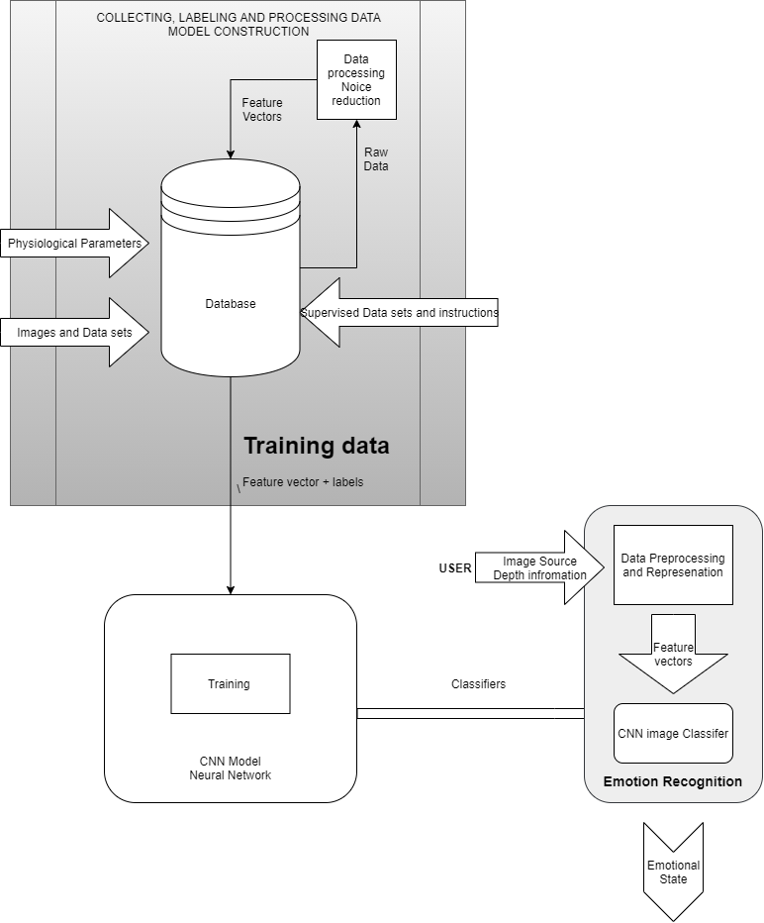

1. **LITERATURE SURVEY:**
2. Busso, C., Deng, Z, Yildirim, S., Bulut, M., Lee, C. M., Kazemzadeh, A., & Narayanan, S. (2004, October). *Analysis of emotion recognition using facial expression , special and multimodal information*. In proceeding of the 6th international conference on Multimodal interface(pp.205-211)
3. Sebe, N., Lew, M. S., Sun, Y., Cohen, I., Gevers, T., & Huang , T, S, (2007). *Authentic facial expression analysis. Image and Vision Computing*, 25(12), 1856-1863.
4. Wan, S., & Aggarwal, J. K. (2013, April). *A scalable metric learning-based voting method for expression recognition* . In Automatic Face and Gesture Recognition (FG), 2013 10TH IEEE International Conference and Workshops on (pp. 1-8). IEEE,
5. [OpenCV Dev Team] “*Welcome to opencv documentation!*” Dec 31, 2019 , Access Online: September 9, 2020 , Available : <https://docs.opencv.org/2.4/index.html>
6. M. Xiaoxi, L. Weisi, H. Dongyan, D. Minghui and H. Li, "*Facial emotion recognition*," 2017 IEEE 2nd International Conference on Signal and Image Processing (ICSIP), Singapore, 2017, pp. 77-81, doi: 10.1109/SIPROCESS.2017.8124509.
7. Turabzadhe, s. *Automatic Emotion State Detection and Analysis on Embedded Device*. Ph.D. Thesis, Brunel University London, UK, August, 2015.
8. Ekman, P.; Friesen, W.V.; Hager, J.C. *Facial Action Coding System the Manual. In Facial Action Coding System*; Consulting Psychologists Press: Palo Alto, CA, USA, 2002 Available online:

<http://face-and-emotion.com/dataface/face/manual/TitelPage.html> (accessed on 23 November 2017).

1. D. Reney and N. Tripathi, "*An Efficient Method to Face and Emotion Detection*," 2015 Fifth International Conference on Communication Systems and Network Technologies, Gwalior, 2015, pp. 493-497, doi: 10.1109/CSNT.2015.155.
2. Turabzadeh, S,; Meng, H.; Swash, R.M.; Pleva, M.; Juhar, J. *Real-time emotional state detection from facial expression on embedded devices*. In Proceedings of the 2017 Seventh International Conference on Innovative Computing Technology (INTECH), Luton, UK, 16-18 August 2017; pp.46-51.
3. “TensorFlow Core”[Online] Accessed: September 9, 2020 ,Available : <https://www.tensorflow.org/guide>
4. C. Jain, K. Sawant, M. Rehman and R. Kumar, "*Emotion Detection and Characterization using Facial Features*," 2018 3rd International Conference and Workshops on Recent Advances and Innovations in Engineering (ICRAIE), Jaipur, India, 2018, pp. 1-6, doi: 10.1109/ICRAIE.2018.8710406.
5. **METHODOLOGY:**

The detection and recognition implementation proposed here is a supervised learning modal that will use the one-versus-all (OVA) approach to train and predict the seven basic emotion (anger, contempt, disgust, fear, happiness, sadness, and surprise).

The overall face extraction from the image is done first using a Viola-Jones cascade object face detector. The Viola-Jones detection framework seeks to identify faces or features known as Haar-like features.

The process entail passing feature boxes over an image and computing the difference of summed pixel value between adjacent regions. The difference is then compare with a threshold which indicate whether an object is considered to be detection or not. This require thresholds that have been trained in advance for different feature boxes and features. Specific feature boxes for facial features are used, with expectations that most faces and the features within it will meet general conditions.

Algorithmic Description for Face Recognition

Let X = \{ x_{1}, x_{2}, \ldots, x_{n} \} be a random vector with observationsx_i \in R^{d}.

1. Compute the mean \mu

\mu = \frac{1}{n} \sum_{i=1}^{n} x_{i}

1. Compute the the Covariance Matrix *S*

S = \frac{1}{n} \sum_{i=1}^{n} (x_{i} - \mu) (x_{i} - \mu)^{T}`

1. Compute the eigenvalues \lambda_{i} and eigenvectors v_{i} of S

S v_{i} = \lambda_{i} v_{i}, i=1,2,\ldots,n

1. Order the eigenvectors descending by their eigenvalue. The k principal components are the eigenvectors corresponding to the k largest eigenvalues.

Essential, in a feature–region of interest on the face it will generally hold that some areas will be lighter or darker than surrounding area. For example, it is likely that the nose is more illuminated than sides of the face directly adjacent, or brighter than the upper lip and nose bridge area. Then if an appropriate Haar-like feature, is used and the difference in pixel sum for the nose and the adjacent regions surpasses the threshold, a nose is identified. It is to be noted that Haar-like features are very simple and are therefore weak classifiers, requiring multiple passes.

1. **Hardware and Software Requirement**

* Hardware specification:

Processor: Intel core Duo 1.2 GHz or higher

AMD Ryzen 2 1.0 GHz or higher

Ram: 2 GB DDR4 2400 MHz or higher

Host OS: Windows 7 SP1, Ubuntu Linux 16.07 or higher with webcam support

* Software specification:

Front-End: ` Python, C++

Development Environment: JetBrains Pycharm 2020.2.1

Back-End: OpenCV 2.4.13.7,TensorFlow Core 2.3.0

UI Interfacing: PyQt, Tk

VCS (Version Control System): Local – Git 2.27

Cloud- Microsoft Github

`